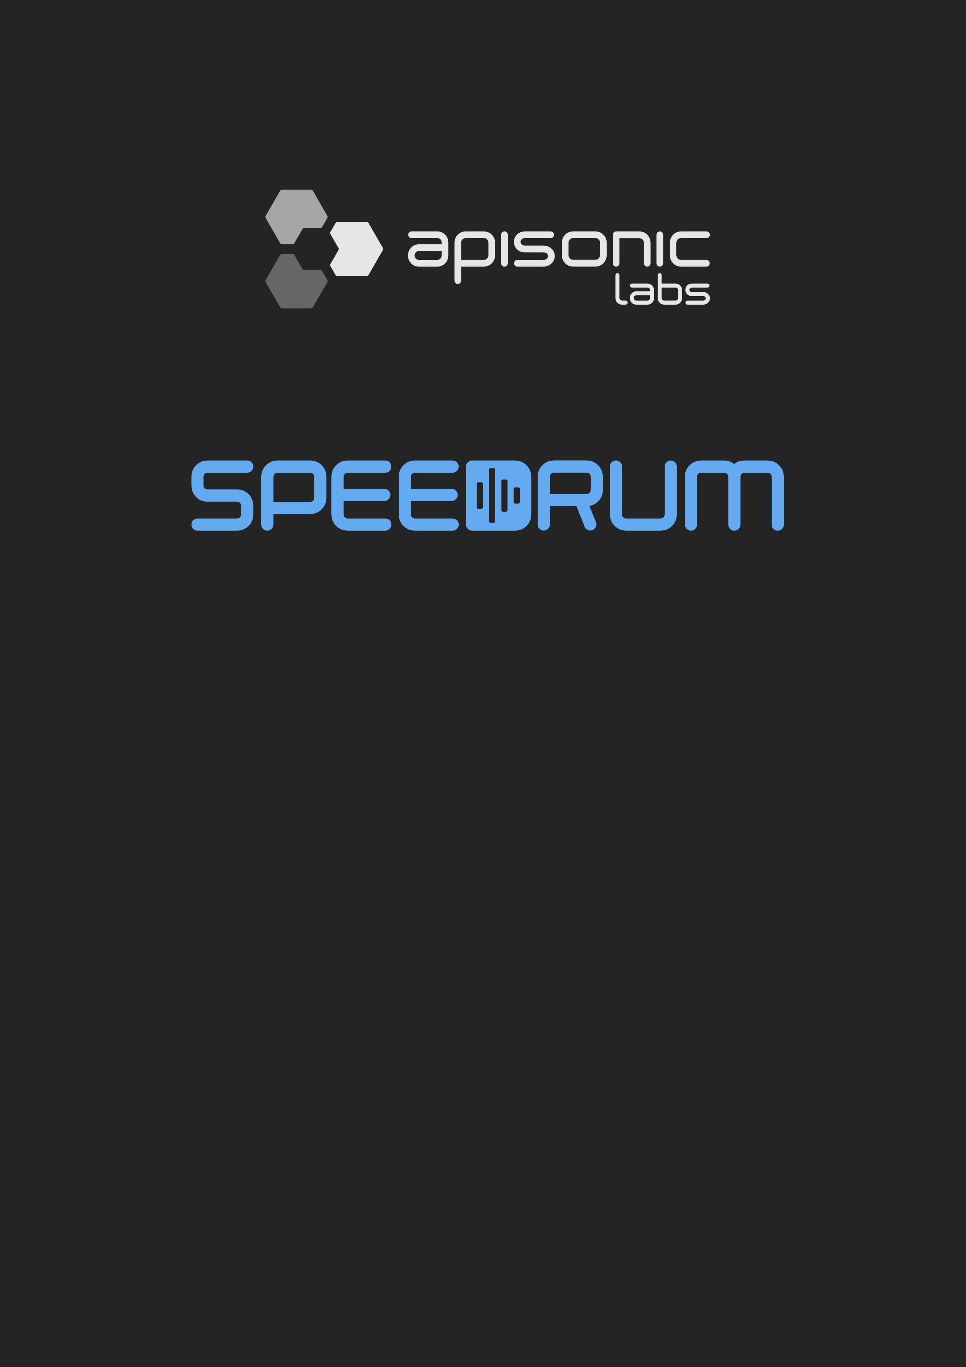

User Guide

version 1.3.0

Table of Contents
Quick Start 3
Header 4
Preferences 5
Browser 6
The Drum Pads 7
Main Controls 9
Modulation Controls 10
FX Section 11
Layers 12
Slicer 15
Sends / Master 16
Setup 17
FAQ 18

Quick Start

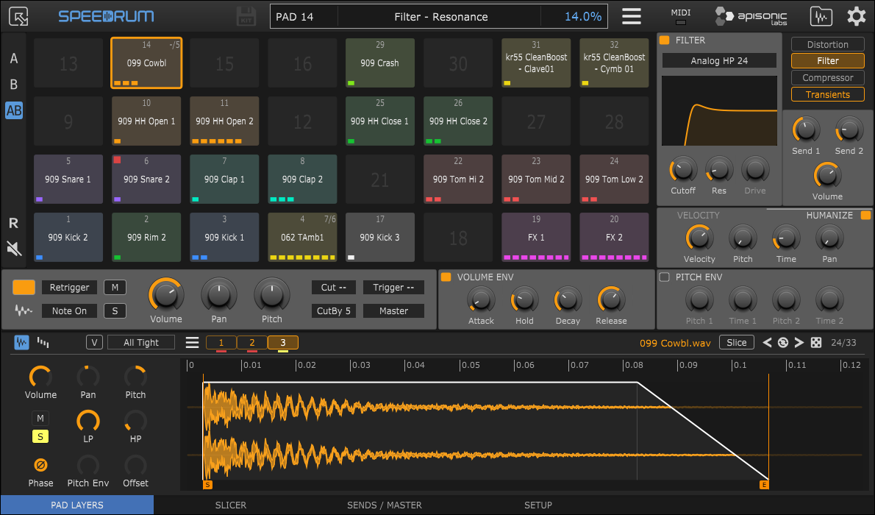

To quickly start, load Speedrum into your preferred plugin host / DAW, and then just drag and drop the audio sample(s) from a plugin host sample browser or a system file manager to a Pad or Layer editor. Layer editor will show the waveform of a loaded sample and layer controls will be available for adjusting. Left-click on a Pad to play it, or use your midi controller.
Or drag and drop an audio loop in to the Slicer tab, so it can be sliced to individual drum hits, which you then drag to every pad you want as a single sample.

Supported audio file formats are WAV, AIFF, FLAC, MP3 and OGG.

TIP - if you plugin host support it Pad name will be visible in a plugin host Piano Roll (only for VST/VST3 version of a Speedrum)

Header

Resize - set plugin window size for this instance of a plugin

Speedrum logo - open About page on mouse left-click

Save drumkit - button to save drumkit ( enabled if kit was changed )

Central label - displays all relevant information

Main menu:
- New DrumKit
- Load DrumKit
- Import
  - Lite kit - will import kit saved with Lite version (only Sample AHD Hold parameter will not be imported, because in a Speedrum it is automatic on a sample level)
  - Poise kit - will partially import Poise (by One Small Clue) drumkit, some of non-compatible parameters will be skipped
- Save Drumkit
- Save DrumKit + Samples - will save drumkit file and all samples in a sub-folder named like a drumkit file
- Set Outputs - shortcuts to set output channels for all pads on A/B set at once
- Download User Guide - open Speedrum web page
- Check for Updates - check latest stable version
- About - some info about the plugin and the system

MIDI - MIDI-IN LED indicator

Browser - toggle sample/kit browser

Preferences - toggle Preferences page

Preferences

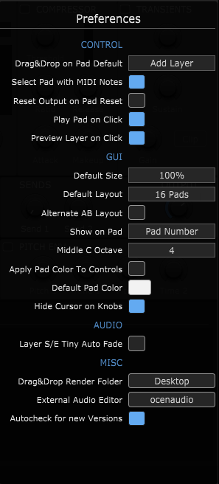
CONTROL
- Drag&Drop on Pad Default - default behavior for sample drop on a Pad - Alt/Option key will override this and do the opposite
- Select Pad with MIDI Notes - when plugin host not playing
- Reset Output on Pad Reset - option to reset also Output channel when a Pad is reset
- Play Pad on Click - whether a mouse left-click on the pad will play that pad or just select it
- Preview Layer on Click - whether a mouse left-click on the layer will preview that layer or just select it

GUI
- Default Size - plugin window size for new instances
- Default Layout - set 16 or 32 pads layout for new instances
- Alternate AB Layout - put B set of pads on top of A set of pads in a 32 pads layout (default is B right of an A)
- Show on Pad - change what is displayed on a Pad
- Middle C Octave - according to what middle C octave to display the notes numbers
- Apply Pad Color to Controls - apply active Pad color to all active Pad controls, otherwise controls will have default plugin color
- Default Pad Color - default color for pads on new drumkit
- Hide Cursor on Knobs - hide mouse pointer when dragging knobs

AUDIO
- Layer S/E Tiny Auto Fade - automatic fade for Start (0.1ms) and End (3ms) layer sliders, this comes in very handy when Humanization is on to eliminate clicks and pops due to sudden transitions

MISC
- Drag&Drop Render Folder - will be used to save drag&drop rendering to Pad or DAW, unless overriden with folder selection in the Setup tab
- External Audio Editor - browse to binary of an audio editor on your system
- Autocheck for new Versions - automatically checking for a new version of a plugin

Browser
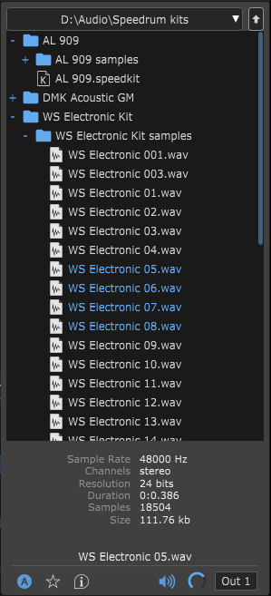
Browser will show drumkits and samples for supported formats.

The arrow keys can be used to navigate the browser, while RightArrow will preview selected sample.
Return key will load selected drumkit, or it will load sample in the visible tab (LAYERS or SLICER).
If it doesn't work, check that your plugin host send keystrokes to the plugin (some hosts may not support sending key press info to a plugin).

Audio preview can be toggled with a small speaker icon, and preview volume can be set with a knob. Also the preview output channel can be set to any available output.

The section on the right will show basic info (sample rate, channels, etc.) for the selected sample, or name and cover art for the selected drumkit.

There are 10 slots for a folder fast access.
Left-click on a slot will set the browser to that location, right-click on a slot will set a slot shortcut for the currently opened location, and Alt/Option + right-click will empty the slot.
The first slot is a default location for new instances.

Double-clicking on a drumkit will load it.
Select one or multiple samples and drag & drop to Pad, Layer buttons or Layer waveform.

The Auto, Favorite folders or the Info can be selected with the buttons on the bottom left.

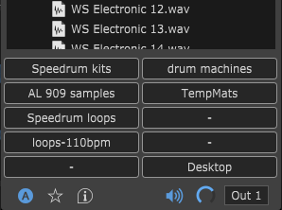
TIP - set the drumkit cover art by putting a .png or .jpg file (200x200 pixels) of the same name as the drumkit file in the folder next to the drumkit file

The Drum Pads
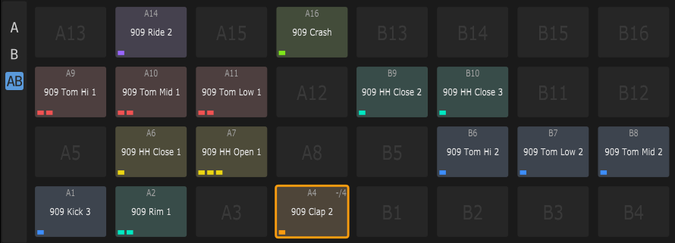
Speedrum has 32 Drum Pads. Each Pad can have up to 8 layers, and each layer can load one sample. Each Pad is triggered by one MIDI note.

Drum pads can be swapped by drag & drop, and copied by Alt/Option + drag & drop.
Standard Cut, Copy, Paste shortcuts can also be used.
Delete key or middle-click will reset the pad.
AWSD keys and Arrow Keys can be used to change the selected drum pad.
(If browser is open, Arrow Keys are used to navigate the browser)

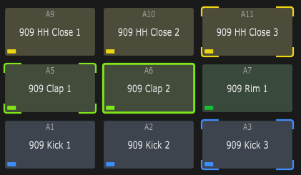
Multiple Pads can be selected at once for a multi-edit functionality.
Ctrl/Command + left-click on a Pad will add/remove it from multi-selection.
Multi-selection can also be achieved by mouse right-button drag, or adding to selection while holding Ctrl/Command.

Ctrl/Command + left-click on a layout button
( A / B / AB ) selects all pads from that layout.

When in multi-edit mode, any change to an active Pad will be applied to all other Pads in a multi-selection (volume, out channel, color...).

Pads layout can be set with A / B / AB buttons.
A = shows pads 1 to 16
B = shows pads 17 to 32
AB = shows all 32 pads

In the AB layout, pads can be in a default A set and B set left to right or in an alternative form where B set is on top of A set (settable in a Preferences).

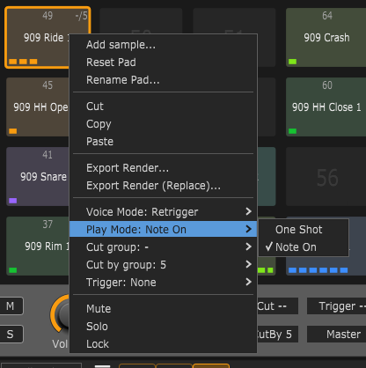
Pad context menu:

- Add sample... - open system file manager to load sample
- Reset Pad(s) - Clear Pad (Pads if multi-edit) data
- Rename Pad
- Standard Cut, Copy, Paste
- Export Render... - to file (with maximum velocity, ignore Humanization)
- Export Render (Replace)... - same as above but replaces Layers with rendered sample after exporting the render
- Voice Mode - see Main Controls
- Play Mode - see Main Controls
- Cut group - see Main Controls
- Cut by group - see Main Controls
- Trigger - on note on trigger selected Pad 1-32
- Mute - mute the Pad
- Solo - solo the Pad
- Lock - locked drum pads will be skipped when loading drum kits

TIP - Shift + left (right) click on a Pad will mute (solo) selected pads

Main Controls

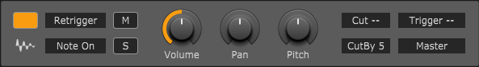
Main Controls of a Pad:

- Color - there are 12 colors that can be assigned to each Pad for better recognition, default pad color can be set in the Preferences
- Waveform-button - drag&drop to export rendering of the Pad (Rendering Folder or Project Folder if specified will be used for saving files)
- On Windows and MacOS - can be droped to other Pad or outside Speedrum (DAW or folder)
- On Linux - can be droped to other Pad
- Voice Mode - Retrigger - active sample layers will be silenced, sound will not overlap
- Poly - active sample layers will continue to play, sounds will overlap
- Play Mode - The play mode option controls how a drum pad responds to MIDI note-off events.
- One Shot - pad will play all the way through, ignoring any MIDI note-off events, release knob will be disabled in this mode
- Note On - pad will play until it receives a MIDI note- off event. If the amplitude envelope is off, the pad will be silenced immediately, if the amplitude envelope is on it will begin the release stage.
- Mute / Solo
- Volume - Pad volume - after the sum of all layers, and before FX processing
- Pan - Pad pan/balance
- Pitch - Pad pitch +/-12 semitones
- Cut / Cut By - There are 8 Cut groups. When a pad assigned to a 'Cut' group is
triggered, any pads assigned to the corresponding 'Cut By' group will be silenced
- Trigger - on note on trigger selected Pad 1-32
- Output - Each Pad can be set to one of 16 individual stereo outputs, first stereo output is Master output

TIP - some knobs snap to specific values (like Pitch), with an Alt/Option key moving knob will ignore snapping

TIP - double-clicking the knob will reset its value to default

TIP - for fine control, hold down a Shift key on your computer keyboard before adjusting
the knob

TIP - there are option in the Preferences to apply Pad color to all controls

TIP - right-click a knob to show the MIDI Learn context menu - MIDI Learn is parameter based

Modulation Controls

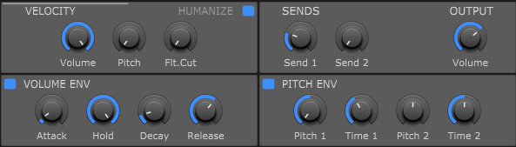

Volume Envelope:
AHD(R) (Attack, Hold, Decay, Release) type Pad envelope with 0 - 15 seconds for every segment
Release will be enabled only in a “Note On” Play Mode

Pitch Envelope:
Pitch envelope is Pad based, but the amount it will affect the Pad Layer is controlled on a Layer with a “Pitch Env” knob
Pitch 1 - the initial sample pitch shift amount
Time 1 - time taken to travel to the second envelope point
Pitch 2 - the second sample pitch shift amount
Time 2 - time taken for the pitch envelope to finish

Velocity:
- to Pad Volume
- to Pad Pitch (0 - 12 semitones)
- to Filter Cutoff in a FX Section (0 - 100 %)

Humanize:
- Velocity (+/- 40 %) maximum amount to randomize the trigger velocity
- Pitch (+/- 2 semitones) maximum amount to randomize sample pitch
- Time (0 - 50 ms) maximum time to delay the sample start
- Pan (+/- 40 %) maximum amount to randomize sample pan

Sends/Output:
- Send 1 - the amount of pads output to be sent to Delay or direct output for external processing
- Send 2 - the amount of pads output to be sent to Reverb or direct output for external processing
- Output Volume - the final output volume of the Pad, after FX processing

TIP - when Humanizize is on check the “Layer S/E Tiny Auto Fade” in the Preferences to eliminate clicks and pops due to sudden transitions

FX Section

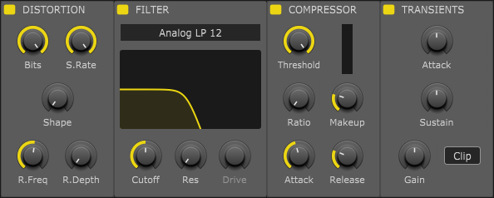

Each drum Pad has a dedicated FX Section with four essential effect.
The effect’s section changes its layout depending on the layout of the Pads.
All effects have a Power button, so can be activated/deactivated.

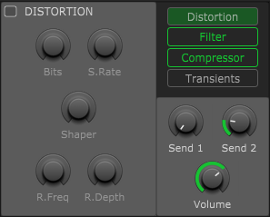
Distortion includes controls for:
Bits - bitcrusher
S. Rate - sample rate reduction
Shaper - waveshaping
R. Freq - ring modulation frequency
R. Depth - ring modulation depth

Filter has 2 type, Analog and Ladder
with 3 mode lowpass, bandpass and highpass all with 12 / 24 dB slopes
Cutoff and Resonance controls can be controlled simultaneously, dragging on the filter response curve.
Ladder type has additional Drive parameter.

Compressor is classic VCA type with all essential controls.
It is used for adding punch and to control dynamics.
Ratio knob snaps to specific values but can be fine-tuned with Alt/Option key modifier.
Simple reduction meter show gain reduction.

Transients is a simple transient shaper with two parameters, Attack and Sustain.
It also includes an overall Gain parameter and a Hard Clipper.

Layers
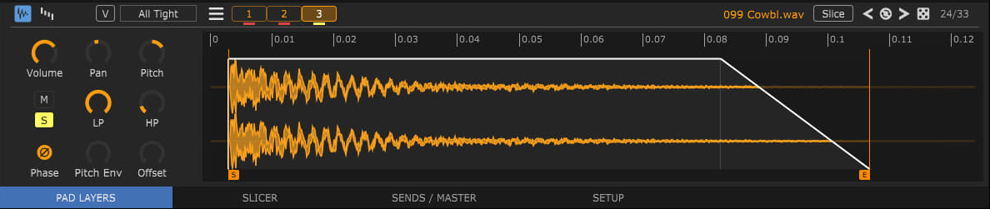

The lower pane of a plugin window contains PAD LAYERS, SLICER, SENDS / MASTER and SETUP and tabs.

LAYERS tab shows all the Layers (with a loaded sample) of an active Pad. Every Pad can have up to 8 Layers, and every Layer can load one sample.
Left-click on a Layer number or the waveform will make that layer active, and preview the audio of the layer if host not playing.
Multiple sample layers can be selected at once for quick editing with Ctrl/Command + left-click,
or Ctrl/Command + right-click on any layer button will select all layers.
Layers can be swapped, or can be moved to a different Pad (copied with Alt/Option) by drag and drop.
Delete layer(s) with middle-click on a layer number.

TIP - Shift + left (right) click on a Layer will mute (solo) selected layers (same behavior as on Pads)

Layer menu (hamburger icon):
- Delete - unload sample and reset the layer
- Duplicate - add a duplicate of an active layer at the end of layers if not all 8 layers used already
- Normalize - normalize a sample to 0dB, -3dB, -6dB, it is non-destructive and can be undone
- Reverse - reverse the sample
- Channels - for stereo samples selectable Stereo, Mono (L + R), Left and Right, also non-destructive and can be undone
- Export - Slice - if in a Slice mode, slice can be exported as a new wav sample file, with the option to reload afterwards so that the layer will no longer be a Slice
- Render - to file (ignore Pad params), with the option to reload rendered afterwards
- Sample File -
    - Show - shows the sample using system default file manager
    - Load in Slicer - load the sample file in the Slicer tab
    - Edit with (editor) - open sample file in a selected (in Preferences) audio editor

Layer can be set/unset in a Slice mode with the Slice toggle button, which will be disabled if the selection is full-length or Normalize, Reverse, or Channels state is on.
When in the Slice mode, editing is the same as if it were an independent sample, although it is actually only part of the sample. Also, exiting from Slice mode will reset Normalize, Reverse, or Channels state previously applied to the slice.
Layer will automatically be in the Slice mode if a part of the loop was dragged from the Slicer to the Pad.
Each Pad has a Layers Mode parameter. It determines which layers are played when a drum pad is triggered.

Pad Layers Modes:
- Single - when a Pad is triggered, only the active (selected) layer will play
- Round Robin - the next layer will be played each time the Pad is triggered
- Random - a random layer will be played each time the Pad is triggered
- Random Exc - (random exclusive) same as Random, but does not repeat the last played
- All Tight - default mode - all layers will be played, the humanization is calculated once and used for all layers

All mods can additionally respect velocity ranges (“V” button) - triggering according to the MIDI note velocity, and layers velocity ranges can be edited (see Velocity ranges view)

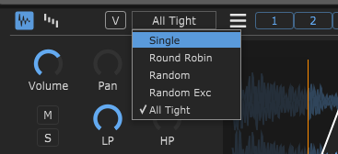

Every layer has a set of dedicated controls:
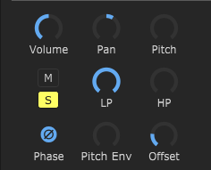
- Volume - layer volume
- Pan - layer pan
- Pitch - adjusts the pitch of the sample layer. (+/- 12 semitones)
- Mute/Solo
- LP, HP - Low-pass and High-pass filter
- Pitch Env - amount of Pad Pitch envelope applied to a Layer
- Phase - invert the phase of a sample
- Offset - the offset control delays the start of a sample when the pad is triggered

There are two views in a Layer editor (can be switched with first two buttons on the editor header):

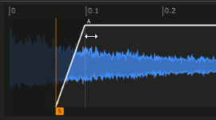
Waveform view - default view - sample waveform view of the selected Layer

With a simple mouse drag you can set a Start / End of a sample and also an Attack / Decay of a sample AHD envelope.
Selection can be moved left right with Alt/Option + drag.

You can also zoom waveform view horizontally to get a closer look:
- ruler drag up/down and left/right to zoom and move
- double-click on a ruler resets view to full
- Alt/Option + double-click on a ruler zoom to selected area (Start-End sliders)
- mouse wheel up/down to zoom in/out on a mouse pointer
- mouse middle-click + drag to move zoomed area left/right
- Ctrl/Command + left/right-click sets start/end marker to mouse pointer

Top right corner contains the name of the loaded sample with the number of samples in a current folder, and the Slice mode toggle button. Double-click on a sample/loop name will open a Browser and select that sample file.
There are also some buttons for fast loading sample from current folder, with the autoplay:
- previous sample
- reload current sample
- next sample
- random sample

Holding Alt/Option while changing the file will try to preserve Sart/Eend/Attack/Decay state.

The far right is the ordinal number of the sample file in the total number of files in the current folder.

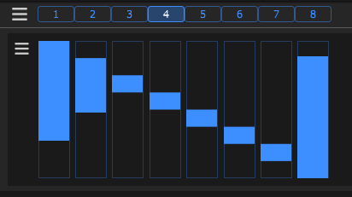
Velocity ranges view - velocity ranges of all Layers
The velocity ranges work in conjunction with all Play Modes and can be used to program velocity splits.

The velocity menu contains commands for spliting, inverting, reseting and moving overlaps.

Slicer

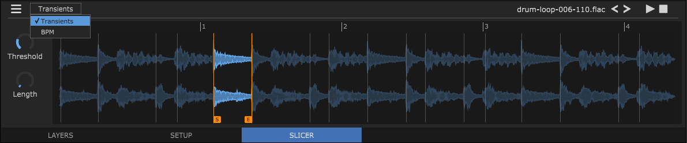
With Slicer, the drum loop can be cut into individual drum hits which can then be loaded into the Pads as normal samples.
There are two slicing modes:
In Transients mode, slicing will look at transients/onsets and the process can be controlled with two knobs, Threshold and Length. The Threshold knob will set the sensitivity when looking for transients/onsets, while the Length knob will set the minimum length of a slice.
In BPM mode, slicing will be processed with the beats per minute base and can be controlled with two parameters. The BPM knob will set the desired beats per minute (hold Alt/Option for 0.1 rezolution), while the Division knob will set additional divisions of a beat.

A slice can be selected with the left mouse button. When selected, start and end of a slice can be changed with the Start/End slider. Moving a transient/onset marker over the other will delete that marker. Additional transient/onset markers can be created with the Shift + left-click on the loop.

The slices can be dragged and dropped onto the pads to populate pads or layers on a specific pad. Ctrl/Command + drag will take selected slice plus all the slices to the right of the selected, so for example, to drag all slices at once hold Ctrl/Command while start dragging first slice.
When dropping on pads, “Drag&drop on Pad Defaul” from preferences is respected, which can be temporarily switched with holding Alt/Option key.

TIP - On Slicer's tab, change of the knob will take effect after you release the mouse button, also mouse wheel on the knob is very handy here

Sends / Master

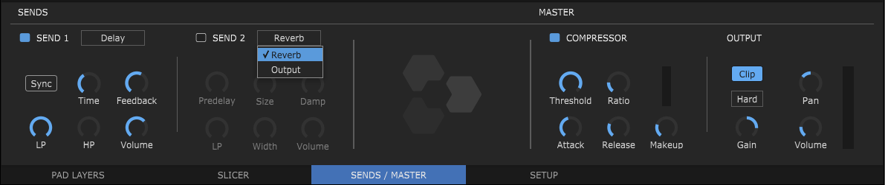
Sends / Master tab provides two Send fx/out slots and master output channel FXs.
Send can be FX, first slot has a Delay while second has a Reverb effect, or it can be a direct output to send signal to external effect. If it is Delay or Reverb, then the signal is forwarded to the main output channel. In the case of the direct output the signal is not returning to the master channel.

Delay includes controls for:
Sync - sync the delay to your host's tempo with the selected note value
Time - when Sync is on, it will give a note values - right-click will bring the menu to choose from
- when Sync is off, it will control the delay in seconds(milliseconds)
Feedback - amount of repeating echoes, a value of 0 produces only one echo
LP / HP - lowpass and highpass filter
Volume - output volume of the delay

Reverb includes controls for:
Predelay - a short amount of delay (0-500ms) before the reverb takes effect
Size - sets the room size, affecting how long the reverberation lasts
Damp - amount of absorption in the room from the environment
LP - lowpass filter
Width - higher values increase the stereo effect
Volume - output volume of the reverb

Output - send can be set to any of the available direct output channels, so it can be used to easily send the amount of the output of an individual pad to an external effect

Compressor is classic VCA type with all essential controls.
It is used for adding punch and to control dynamics.
Ratio knob snaps to specific values but can be fine-tuned with Alt/Option key modifier.
Simple reduction meter show gain reduction.

The Clipper can be Soft or Hard, and its input can be adjusted new using Gain.

TIP - the peaks on the meter can be reset by clicking on the meter itself

Setup
The Setup tab contains the settings related MIDI, but also some settings exclusive to the current instance of plugin.

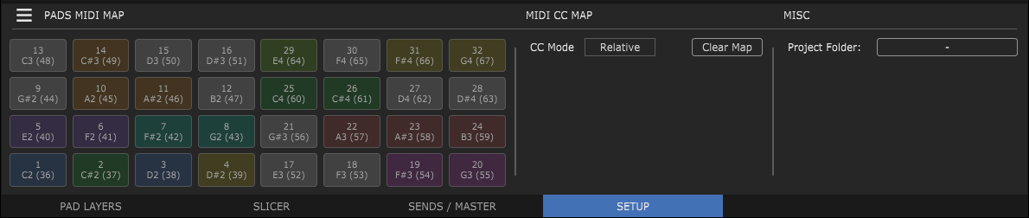
Pads MIDI Map (trigger map)

A trigger map contains 'region' information for each drum pad. In other words it controls what MIDI notes trigger which drum pad. Every pad respond to a single MIDI note.

For pad to learn a trigger note just left-click on a pad note/number you want to learn in the Setup tab and then press a key or pad on your MIDI controller or a DAW Piano Roll. It will change the pad text according to the newly learned note.

To manually set pad to a specific midi note number, right-click on a trigger button to get a dialog for entering number.

Saving and loading of trigger maps is supported from a Pads MIDI Map menu.
Also, it is possible to set the current trigger map to be the default map for all new instances.

MIDI CC Map

Midi CC map contains GUI control links to midi cc parameters.
There are two operating modes for receiving cc messages, so it can be set to correctly recognize the mode from the sender:
Absolute - received messages are interpreted as 0 to 127
Relative - received messages are interpreted +1/-1 (most often come from the endless encoder)

Misc

Project Folder - if selected, will be used to save drag&drop rendering to Pad or DAW, but only for this instance of the plugin, and it overrides Render Folder slected at Preferences. It is useful for storing rendered samples directly in the DAW project folder.

FAQ

What are the system requirements?
- Host software / DAW - 64 bit
- CPU Intel / AMD / Apple M1
- Windows 7 or newer
- MacOS 10.9 or newer
- Linux Ubuntu 18 or newer (experimental = tested on Mint and Manjaro, and will probably work on other linux distributions as well)
What are the restrictions of the Demo version?
Demo version is fully functional with no time restrictions but loading the drumkit and reloading the plugin state is disabled.
Do I need internet to Activate plugin?
No! It is a simple unobtrusive offline activation. When you purchase a license in our online store your purchase will be processed by Paddle and you'll be sent an activation code by email. Then open the demo plug-in, enter your email and activation code when asked, and enjoy your fully-functional, licensed plug-in.
Can I use a license on multiple PCs?
You can use the personal license on all of your computers, and this includes mixed use on Windows/macOS/Linux computers, as long as only you use it.
Apple Silicon compatibility?
The installer will install universal binary that contain separately optimized code for Intel and Apple Silicon processors which will run natively on each platform.

